Document Number:  TCS-XYZ-SDD-VAT-PH1-1.0 | Copy Number: 1.1

Q CITY BANK
HYDERABAD

Name of the Project:Application development for the Q city Bank
Software Design Document for Bank Management
- Version 1.0

8th MAY 2014

This is a controlled document. Unauthorized access, copying, replication and usage for a purpose other than for which this is intended are prohibited.

PF3020
DOCUMENT RELEASE NOTICE
Notice No. | 1
Client | Q City Bank
Project | Application Development for Q City Bank Loan Management
Document details | System Design Document for Loan Management module

Name | Version No. | Description
SDD for Bank Management Application. | 1.0 | Base Version

Revision details:
Action taken  (add/del/chg) | Preceding  page No. | New  page No. | Revision  description

Change Register serial numbers covered:
The documents or revised pages are subject to document control.
Please keep them up-to-date using the release notices from the distributor of the document.
These are confidential documents. Unauthorized access or copying is prohibited.

Approved by : Date:

PF2060C
DOCUMENT REVISION LIST
Client | Q City Bank
Project | Application Development for Q City Bank Loan Management.
Document Name | SDD For Q City Bank Loan Management
Release Notice Reference (for release)

Rev.  No. | Revision  date | Revision  description | Page  No. | Prev  page No. | Action  taken | Addenda/New page | Release  Notice reference

CONTENTS

1 INTRODUCTION 1
1.1 Background 1
1.2 Purpose 1
1.3 Scope 1
1.4 Definitions 1
1.5 Project References 2
1.6 Organisation of the Document 2
2 System Description 3
2.1 Project Functions 3
2.1.1 List of Functions 3
2.2 User Categories 3
2.3 Design Objectives 3
2.4 System Architecture 4
2.5 Technical Architecture 4
2.6 Development Methodology 5
2.6.1 MVC Architecture 5
2.6.2 MVC Architecture applications 5
2.6.3 Business components 5
2.7 Hardware Environment 6
2.8 Software Environment 6
2.9 Network Environment 6
2.10 Assumptions and Dependencies 6
3 Business Functions 8
3.1 Customer Registration 8
3.2 view customer detail 8
3.3 view all customer details 8
3.4 update customer 8
3.5 delete customer 8
3.6 activate ACCOUNT 8
3.7 deactivate account 8
3.8 withdraw money 8
3.9 deposit money 8
3.10 transfer money 8
3.11 provide locker 8
3.12 generate statements 8
3.13 issue cards 8
3.14 give interest 8
3.15 deduct tax 8
4 screens 9
4.1.1 Screens 9
4.1.2 Reports 9
4.1.3 Business Components / Application Modules, Views & Entities 10
4.1.4 Packages 10
5 Screens 12
5.1 SCRVIEWCUSTOMER 12
5.2 SCRVIEWALLCUSTOMER 13
5.3 ScrVIEW 14
5.4 SCRDELETECUSTOMER 16

  - class Diagram-----------------------------------------------------------------19
  - Usecase Diagram-------------------------------------------------------------20
  - Sequence Diagram----------------------------------------------------------- 21
  - ER Diagram-------------------------------------------------------------------22

Total Number of Pages -34

INTRODUCTION

Background

TCS submitted Software Requirements Specifications (SRS) of Q-city Bank on April 7, 2014. and subsequently, YYY provided feedback on the SRS. The current Software Designing Document (SDD) is based on the SRS document and subsequent feedback from Q-city Bank.

Purpose

This SDD for the Q-city Bank application has been prepared to provide a development framework and primarily intended for TCS consultants working on the development and also for Q-city Bank, to provide an overview of TCS’s development perspective.

This document defines the overall system specification in terms of user interface, processes, dataflow, and internal and external linkage to the Core Banking module.

Scope

The scope of the project involves detailed Analysis, Design and Development of computer based application for Q-city Bank, Hyderabad.

The design phase consists of the following stages:

- Database design, Screen design.
- Preparation of SDD based on the functions specified in SRS
- Review of SDD.

Definitions

Table 1-1 List of Abbreviations

Abbreviations | Represents
DO | Development officer

Project References
Table 1-2 Project References

No. | Document | Author | Version
 | Registration – SRS | TCS | 1.1
 | Q-city Bank Feedback summarized and communicated to Q-city Bank on April 11, 2014 | TCS | 08/05/14
 | TCS QMS documents | TCS | Current

Organisation of the Document

The chapters and their contents are given in the following table

Chapter | Name | Content Description
1 | Introduction | This Chapter itself
2 | System Description | Project Functions  List of Functions  User Categories  Design Objectives  System Architecture  Technical Architecture  Development Methodology  Three-tier applications  Business components  Development and deployment  Hardware Environment  Software Environment  Network Environment  Design Constraints  Assumptions and Dependencies
3 | Business Functions | Registration  Screens  Reports  Process Control Objects /Web Beans  Business Components / Application Modules, Views & Entities
4 | Screens | Navigation details Process Steps  Description  Tables referred  Packages (PLSQL procedures)  Beans referred  Business Object

System Description

Project Functions

List of Functions

The different functions of the Life Insurance module are:
- Identification of authenticated Users
- Sign Up activity for the customer representative and clerk.
- Registering customers.
- View, update Changes in customer details.
- View account details and list of accounts under a particular customer.
- Open, close, delete accounts.
- Provide lockers and credit/debit cards to customers.
- Withdraw, deposit and transfer money between two accounts.

User Categories

The users of the System can be categorised as:

Internal Users:

Customer representative
Clerk
Manager

Design Objectives

The quality policy of the system states that the system should be delivered to meet user needs. These needs, as summarized in this document, will form the basis for further design.

For different categories of users, major objective will be to implement the System and utilize it for their day-to-day operations.

The proposed system will provide the users with the following benefits:

- All Branch users of Q-city Bank company will have easy access to information.
- Data inaccuracies will not occur (single point data)
- Faster retrieval of information
- Reduction in manual effort in terms of
- Information maintenance
- Reports generation

The system has been designed to achieve the following objectives:

- to provide efficient and quicker service to all users.
- to provide controlled access to sensitive data
- to provide flexibility to accommodate future needs.
- to eliminate duplication of work.
- to provide complete management control.
- to design the system in line with SRS.
- to provide a convenient and an effective information system.
- to provide decision support system for the management.

System Architecture

The application architecture diagram is given below as per our Technical Proposal:

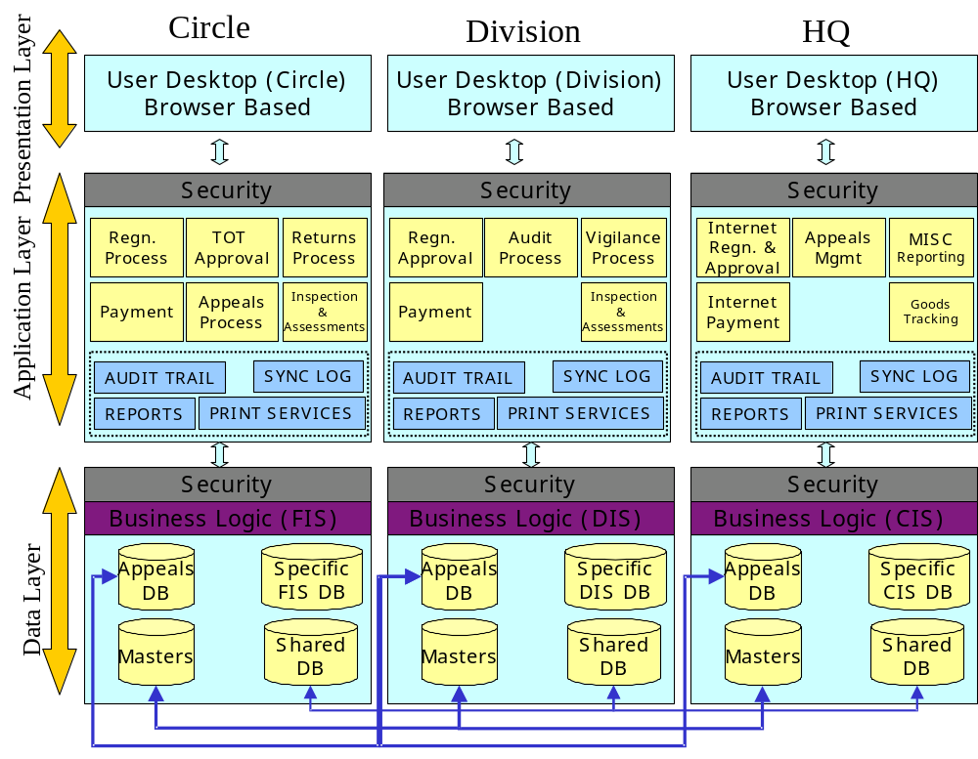
The salient features of the application architecture are as follows:

- The functions are independently distributed across the Application servers distributed across the circles, divisions and head quarters.
- This architecture will allow independent functioning of field offices without any interaction with the central servers in a real-time mode.
- The synchronization of the databases will be done on a daily basis for shared and appeal database and on a weekly basis for the master databases (the updates to the masters is expected to be infrequent as some of them may be due to only the policy changes in the Government).
- The security is at the application server and the data server level.
- The business logic is split across the application and the data layer allowing a 4 tiered architecture provided advanced security and better performance for some of the crucial transactions. Since, some Business Logic is stored in the data layer for retrieval of data and query processing, thus we assume a 4th layer is introduced in the architecture.
- The infrastructure architectural components like audit trail, report generating, synchronization programs and the print services will be configurable for each of the locations.
- The system will work under a well-defined security domain and provide auditing of important data . The output of the system will consist of numerous reports providing the information as per the client’s requirements in each of the aforesaid areas.

Technical Architecture

Following picture depicts the MVC architecture, which will be used for this project. Browser which uses Java and HTML forms the front-end of this application. Oracle 9I Application Server which includes the web server forms the middle layer and
Oracle 9I Database server is used for the data layer.
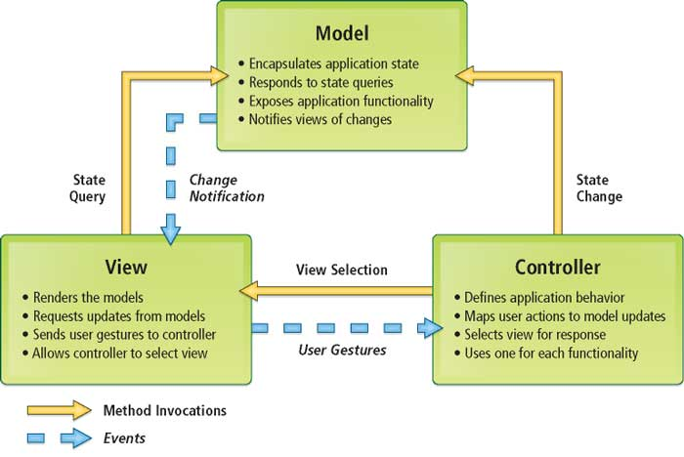

Development Methodology

The development methodology is based on unix platform and oracle platform,GCC compiler is used to develop the business components .

MVC Architecture
Model–view–controller(MVC) is a software pattern for implementing user interface. It divides a given software application into three interconnected parts, so as to separate internal representations of information from the ways that information is presented to or accepted from the user. The model, consists of application data, business rules, logic, and functions. The view can be any output representation of information.The controller accepts input and converts it to commands for the model or view.

MVC Architecture applications

Business Components for MVC architecture that are made of
- Model-a database server containing table and the business logic
- View-a display for output representations
- Controller-controls the model and the view

Business components
The framework defines these business components that are used in the applications:
- application module
- view object
- entity object
- view link
- association
- domain

A business component is implemented using CPP and database is implemented using Oracle.

The business logic tier is made of one or more application modules that contain view objects, representing views of data and optionally including calculations. View objects can use entity objects, representing business entities and mapping to database tables, to enforce business logic.

View links represent master-detail relationships between view objects and are also contained in an application module; associations represent bidirectional relationships between entity objects.

These modular components are easy to customize, maintain, and reuse in other applications. The component-based framework handles many repetitive coding tasks, such as master-detail coordination, locking, and transaction management, including changes in the business logic tier’s data cache and posting changes to the databases.

Hardware Environment

Following is the location specific hardware configuration :
Head Office : RISC Unix Server as Database Server in a cluster (Rack Server)- 2No.
INTEL NT Server as Back-up Server (Rack Server)- 1No.

Local Servers : RISC Unix Server as Application Server (Rack Server)- 1No.

Personal Computers – PIV Model

Processor | Intel Pentium IV @ 1.5 Ghz
Memory | 128 MB SDRAM expandable through 3 DIMM sockets
Hard Drives | 40 GB HDD with ATA 100 interface

Software Environment

Following is the location specific software environment :
Database server:
Oracle 9i Application Server Enterprise Edition on IBM RS6000-AIX platform. Oracle 9I DataBase Enterprise Edition on IBM RS6000 – AIX Platform
End User Terminals :
Browsers (Internet Explorer 5.0 and above/ Netscape Navigator 4.5 and above)

Network Environment

Keeping in view the geographical spread and locations of various branches a fully networked environment is considered. However, the Application is independent of the network architecture that is finally implemented.

Assumptions and Dependencies

- Application development for Q-city Bank SRS – Q-city_Bank_SRS.doc (delivered to Q-city Bank on April 11, 2014) document was used as basis for the design, and that version was assumed as final.
- The efficiency of the system will depend on the efficiency of some of the systems that it interfaces with. Any problem with data integrity in the host system will reflect in data integrity problems in this application also.

Risks

- If there is no timely feedback on design from Q-city Bank, it will have an impact on the development of the system and slippage of schedules.
- Non-availability of Network connectivity, such period may result in the use of the application system as a stand-alone system.

Business Functions

Customer Registration
The customer can be registered in the bank by Customer representative.

view customer detail
The customer detail can be viewed for a particular account.

view all customer details
All customer details can be viewed.

update customer
The customer details can be updated by customer representative.

delete customer
The clerk can delete customer details.

activate ACCOUNT
The clerk can activate customer account.

deactivate account
The clerk can deactivate customer account

withdraw money
The clerk can withdraw money on behalf of customer.

deposit money
The clerk can deposit money on behalf of customer.

transfer money
The clerk can transfer money between two accounts.

provide locker
The clerk can provide lockers to the customers.

generate statements
The clerk can generate detailed statements for accounts.

issue cards
The clerk can provide gold, silver and platinum credit/debit cards to the customer.

give interest
The system can calculate interest based on the balance in the account and add it to the main balance.

deduct tax
The system will calculate tax based on the Fixed deposit amount and deduct it automatically from the amount.

screens

This chapter lists the screens, reports, process control objects, business objects that will be used as part of the registration module.

Screens

S.No | Screen Name | Description
 | ScrLogin | Login Screen
 | ScrMenu | Menu Screen
 | scrCusReg | Customer Registration Screen
 | scrCusView | Customer detail view Screen
 | scrAllCusView | All Customer details view Screen
 | scrUpdtCus | Customer update Screen
 | scrDltCus | Customer Delete Screen
 | scrOpenAct | Opening Account Screen
 | scrLoanView | All Account view Screen
 | scrDeactAcc | Account Deactivate Screen
 | scrDltLoan | Money transfer screen
 | scrwithdraw | Money withdrawscreen
 | scrEMIProj | EMI Projection Screen
 | scrPayemnt | Payemnt Screen
 | scrNotification | Notification Screen

Reports

No. | Report Name | Description
 | MISreport | List of Customers Registered and total accounts

Business Components / Application Modules, Views & Entities

No. | Application Module Name | Method Name | View Object | Entity Name
 | CusRegAppMod | AddCustomerDetail(Row) | InsCusRegView | Customer1
 | ViewCusAppMod | SelectRow(Row) | QryCusView | Customer1
 | UpdCusAppMod | UpdRow(Row) | UpdCusView | Customer1
 | DltCusAppMod | DeleteRow(row) | DltCusView | Customer1
 | DeactCusAppMod | UpdRow(Row) | UpdCusView | Customer1
 | ReactCusAppMod | UpdRow(Row) | UpdCusView | Customer1
 | LoanCrtAppMod | AddLoanDetail(Row) | InsLoanRegView | Loan1  Loan_accounts1
 | LoanViewAppMod | SelectRow(Row) | QryLoanView | Loan1
 | DeactLoanAppMod | UpdRow(Row) | UpdLoanView | Loan1
 | ReactLoanAppMod | UpdRow(Row) | UpdLoanView | Loan1
 | UpdROIAppMod | UpdRow(Row) | UpdLoanROIView | Loan_ROI1
 | Payment | UpdRow(Row) | UpdPaymentView | Payment1  Loan1

Packages

No. | Package Name | Procedures / Functions used | Reference with the URS Input/ Process/ Queries
1 | None | None

Next part is modified by : shibu kumari.

Screens

SCRVIEWCUSTOMER

Name: View Customer Screen

Description:
This Screen is used to capture some information about a customer who has account in Q-city bank.

Tables Referred:

Table Name | Select | Insert | Update | Delete
Customer

Business Components / Application Modules, Views & Entities

SL.No. | Application Module Name | Method Name | View object | Entity Name
1. | AckAppMod | AddRow() | InsAckView | Acknowledgement

Packages Referred:

SL.No. | Package Name | Procedure/Function Name
1. | None | None

Screens Called: None

Reports Called: None

Screen Layout:

Name of Customer :
Age of Customer :
Address of Customer:
Account Number:
Amount:

Field Descriptions :

Sl.No | Field Name | Table/  Column | Validations | MIUQ | LOV (select statement) | Default Value
 | Name of Customer | Customer1:  Customer_name |  | Q | N | None
 | Age of Customer | Customer1:  Customer_age |  | Q | N | None
 | Address of Customer | Customer1:  Customer_address |  | Q | N | None

M- Mandatory: I- Insert: U- Update: Q- Query:

* Specifications : Mention about the field specification like combo box, list values, display item, non-base table,.etc., to be mentioned

Specifications:

Mode | Action (While Saving)
Add | None
Modify | None
Query
Delete | None

Functionality:
- This screen is a screen for displaying a single customer.
- GetCustomerId function is called to take customer id and check would be performed on the validity of the customer.
- The display method is called to fill the data entry section.

SCRVIEWALLCUSTOMER

Name: View All Customer

Description:
This Screen is a Screen to display all customer with their id.
Tables Referred:

Table Name | Select | Insert | Update | Delete
Customer1

Process Control Objects / Web Beans
Web Bean Name | Method Name | Application Module Name
LstRegEntryWB | QryRow() | LstRegEntryAppMod

Business Components / Application Modules, Views & Entities

SL.No. | Application Module Name | View object | Entity Name | Method Name
1. | Customer1:viewallcustomer |  | Customer1 | Select()

Packages Referred:

SL.No. | Package Name | Procedure/Function Name
1. | None | None

Reports Called: None

Screen Layout:
customerName CustomerId
a 1
b 2
c 3

Field Descriptions :

Sl.No | Field Name | Table/  Column | Validations | Specifications* | MIUQ | LOV (select statement) | Default Value
 | CustomerName | Customer1:  Customer_name | QUERY |  | Q | N | None
 | CustomerId | Customer1:  Customer_age | QUERY |  | Q | N | None

M- Mandatory: I- Insert: U- Update: Q- Query:

* Specifications : Mention about the field specification like combo box, list values, display item, non-base table,.etc., to be mentioned

Specifications:

Mode | Action (While Saving)
Add | None
Modify | None
Query | None
Delete | None
Functionality:
- This screen is a list of all the customer with their id ,name, mobile no,

- When the user choose this option of “ view all customer” ,this particualr screen is opened.

ScrVIEW

Name: View Loan

Description:
This Screen is used to display some information about loan.

Tables Referred:

Table Name | Select | Insert | Update | Delete
Loan

Business Objects / Entity

SL.No. | Application Module Name | View object | Entity Name | Method Name
1.

Reports Called: None

Screen Layout :
Loan id :

Loan type id :

Emi :

Sl.No | Field Name | Table/  Column | Validations | Specifications* | MIUQ | LOV (select statement) | Default Value
1 | Loan id | Loan:loan_id |  |  | Q |  | None
2 | Loan type id | Loan:loan_type_id |  |  | Q |  | None
 | Emi | Loan:loan_emi |  |  | Q |  | None

M- Mandatory: I- Insert: U- Update: Q- Query:

* Specifications : Mention about the field specification like combo box, list values, display item, non-base table,.etc., to be mentioned

Specifications:

Mode | Action (While Saving)
Add | None
Modify | None
Query | None
Delete | None

Functionality:
- This screen is used to capture the details of the loan of particular customer.
.
- The getLoanid function is called to take loan id then corresponding loan details will be displayed.

SCRDELETECUSTOMER

Name: Delete Customer

Description:
This Screen is used to capture the id of customer who details needs to be deleted.

Tables Referred:
Table Name | Select | Insert | Update | Delete
Customer

Business Objects / Entity Beans

SL.No. | Application Module Name | View object | Entity Name | Method Name
1.

Packages Referred:

SL.No. | Procedure Name | Function Name
1. | None | None

Screens Called: ScrDeletescreen

Reports Called: None

Screen Layout :

Please enter the customer id :

Field Description :

Sl.No | Field Name | Table/  Column | Validations | Specifications* | MIUQ | LOV (select statement) | Default Value
 | Customer id | Customer:customer_id | DELETE QUERY |  | Q | N | None

M- Mandatory: I- Insert: U- Update: Q- Query:

* Specifications : Mention about the field specification like combo box, list values, display item, non-base table,.etc., to be mentioned

Specifications:

Mode | Action (While Saving)
Add | None
Modify | None
Query | None
Delete | Yes

Functionality:
- This screen is used to capture the id of customer then the customer will be deletd from database.

6. Diagram:

6.1 Class Diagram:

Main classes are:
- Customer
- Account
- Bank
- Validation
- Dbwrapper
- CustomerController
- AccountController
- CustomerController
- BankController
- MainUI
- CustomerUI
- AccountUI
- BankUI

.
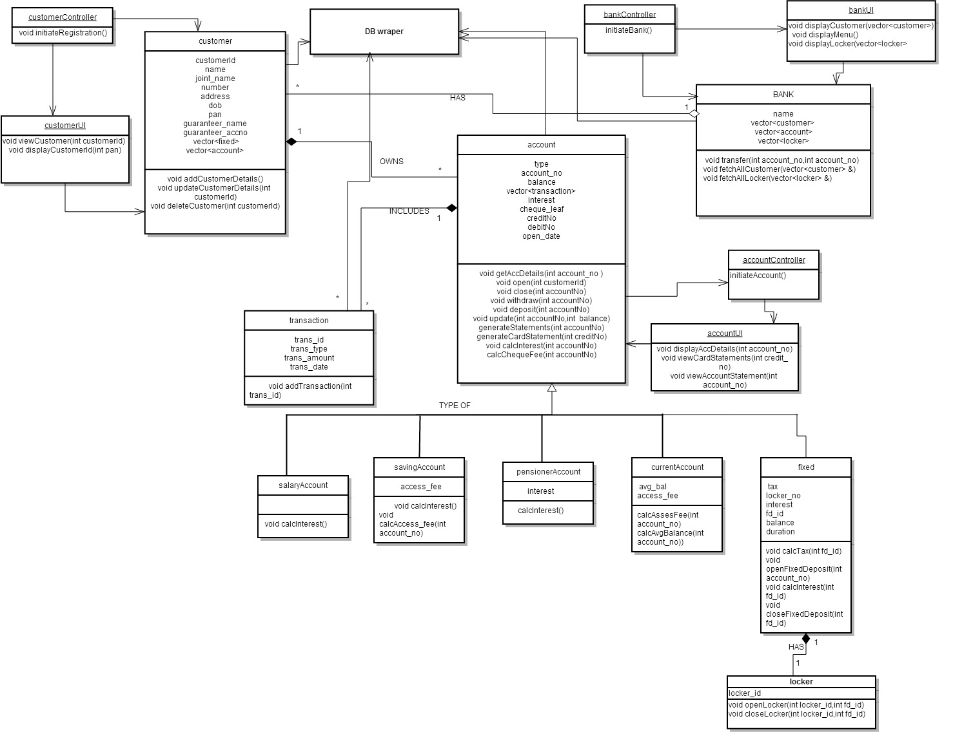
6.2 Usecase Diagram:

Actors are:

- Clerk
- Senior Clerk
- Manager
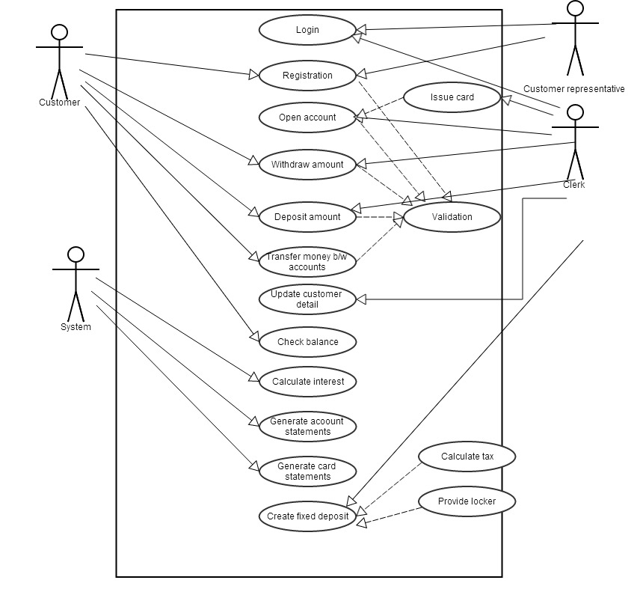
6.3 Sequence Diagram:

REGISTER CUSTOMER

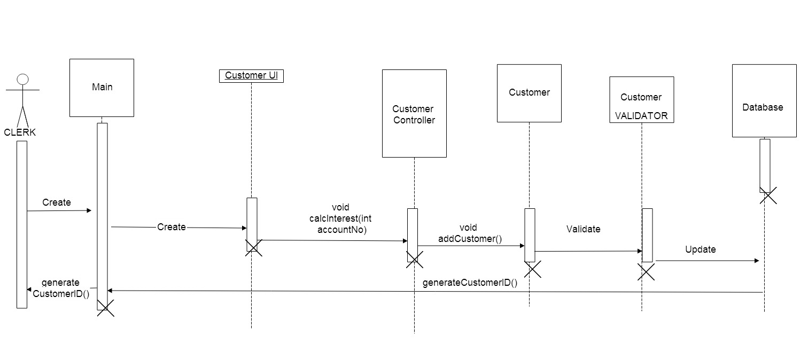

OPEN ACCOUNT
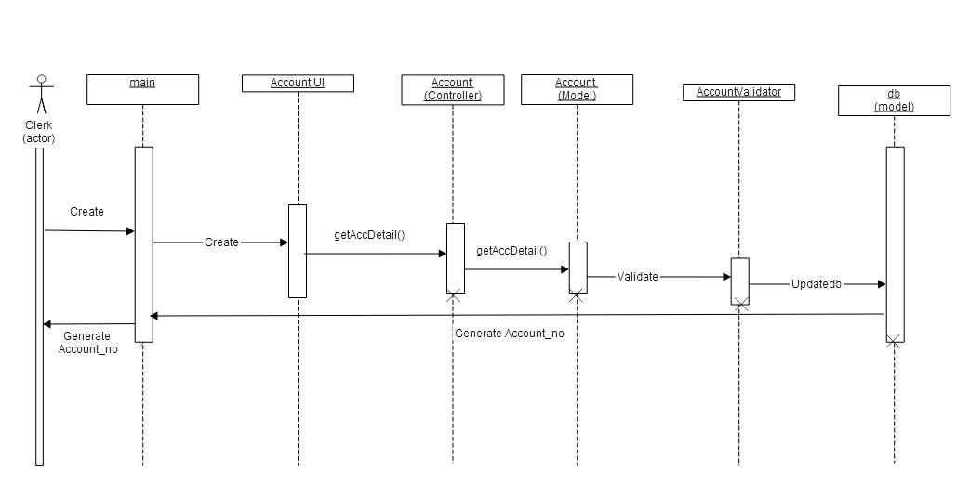

CHECK BALANCE

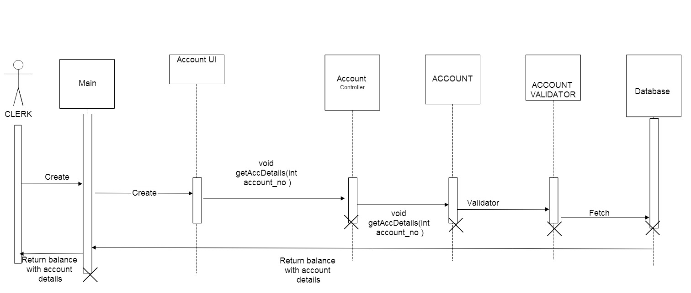

WITHDRAW MONEY
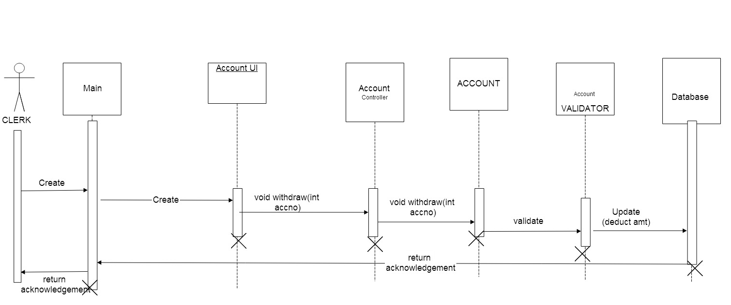

DEPOSIT MONEY
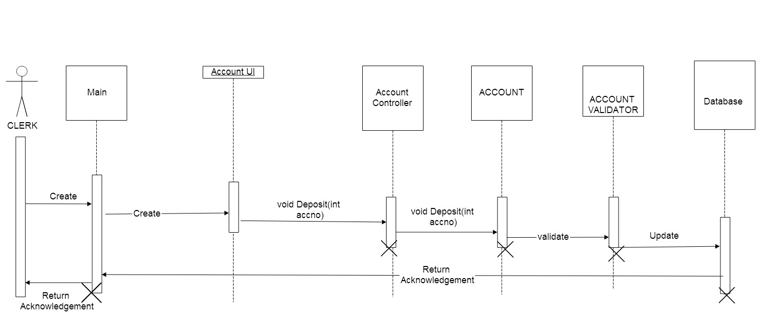

TRANSFER MONEY

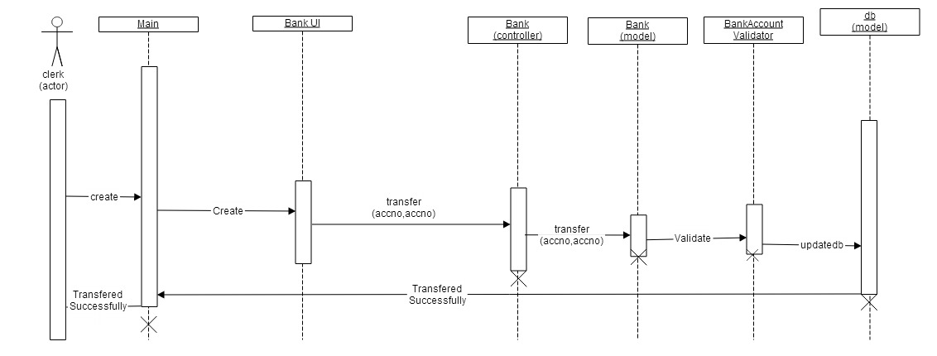
ISSUE CARD

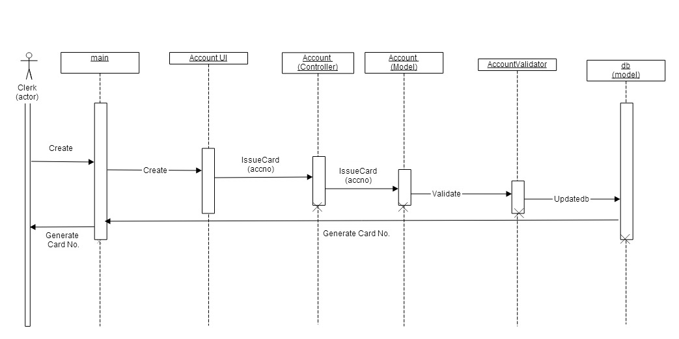

CALCULATE INTEREST

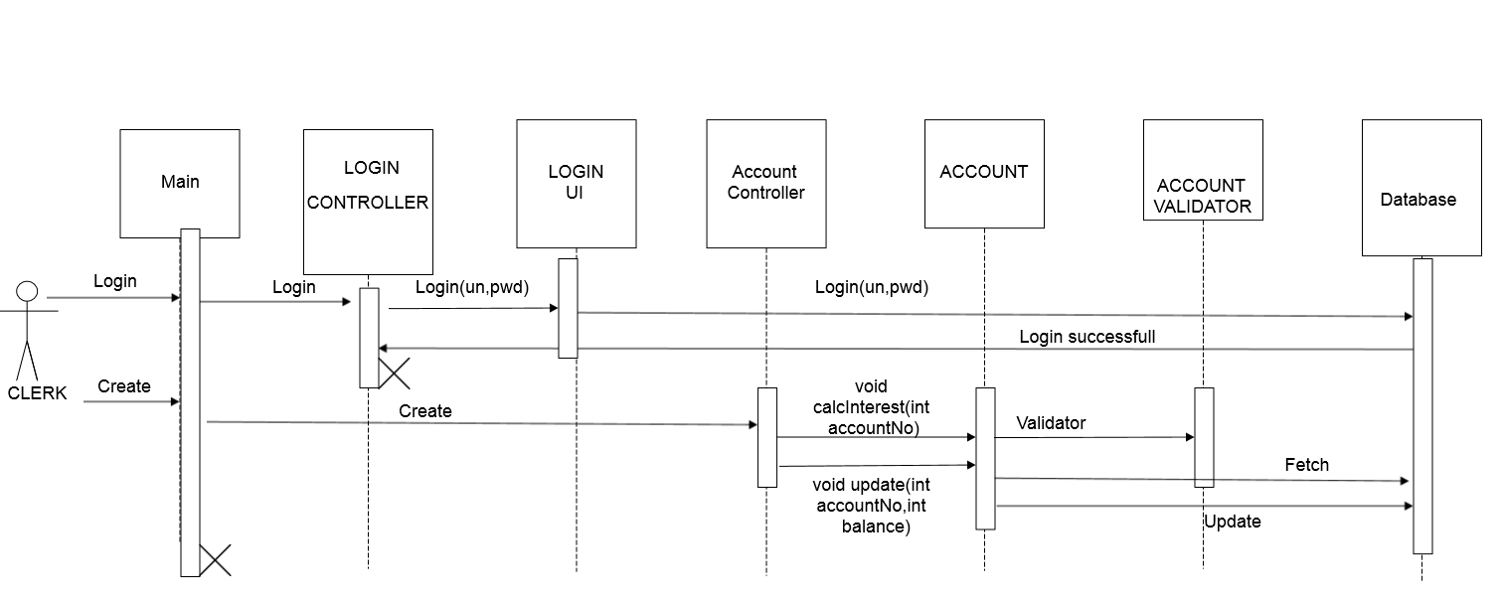

Customer Delete
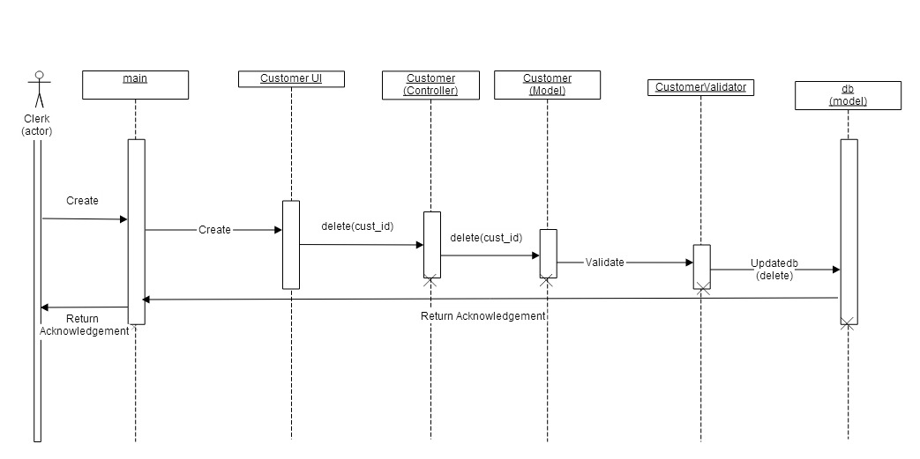

UPDATE DETAILS

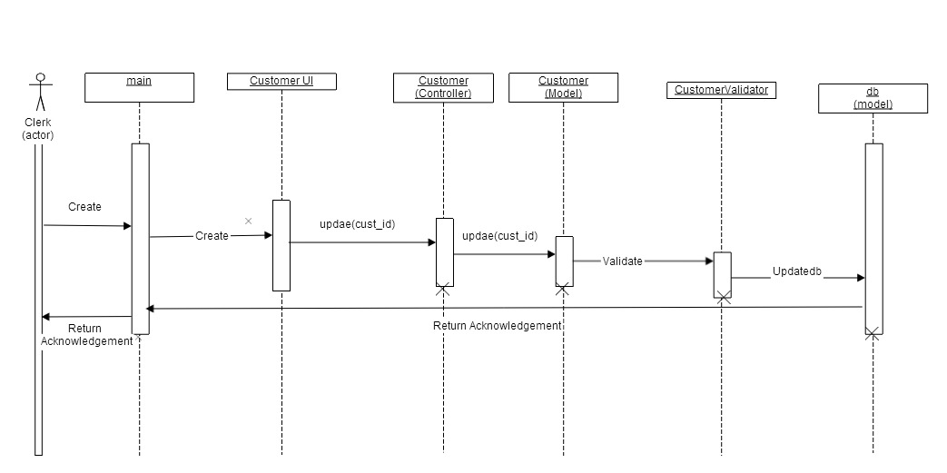
CALCULATE TAX
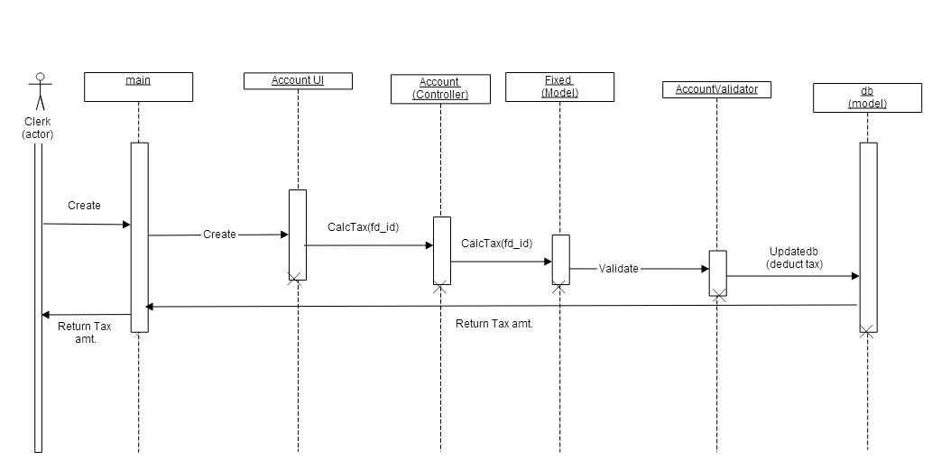

CLOSE ACCOUNT

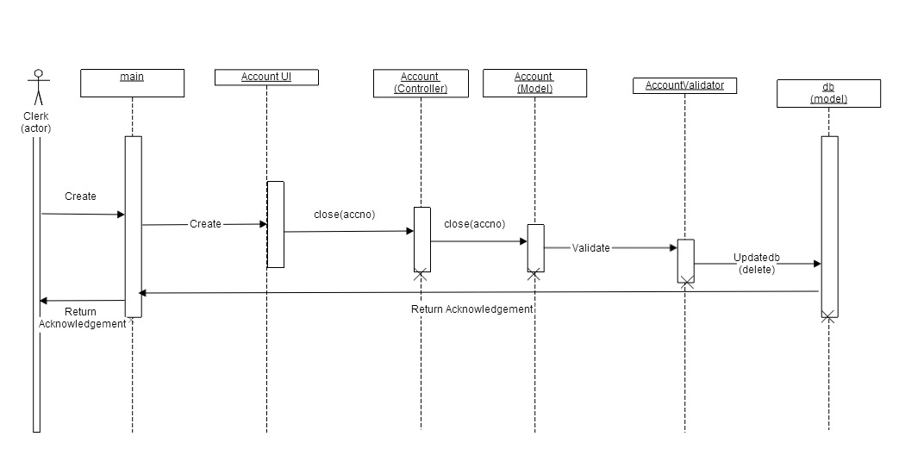
ER Diagrams:

Entities are:
- Customer
- Account
- Bank

